Model Deployment

Name: expense_prediction
Report date: 07/27/2022
Internship Batch: LISUM11: 30
Version: 1.0
Data intake by: Priyadarshani Kamble
Data intake reviewer: NA
Data storage location: https://bitbucket.org/pk_projects/work/src/week4/Income_Expense_Data.csv

Tabular data details:

Total number of observations | 14
Total number of files | 1
Total number of features | 3
Base format of the file | csv
Size of the data | 1KB

Step 1 : Create requirements.txt
The requirements.txt file contain all the dependencies for the flask app. This can be created using below command:
pip freeze > requirements.txt

The folder contains below files.

Deployment on Heroku
Step 1 :
I created an account since I did not have one at www.heroku.com.
Step 2:
Create a new app simply by choosing a name and clicking “create app”. This name doesn’t matter but it does have to be unique.
Step 3: we have few options to deploy the app. Heroku CLI and GitHub. I used GitHub.

Deploying With Github
Connect your github account by clicking the github icon below:
Search for the correct repository and click connect:

scroll to the bottom of the page and click “Deploy Branch”
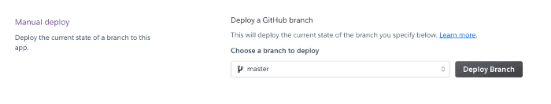

I then received below message. My first few builds failed. I then checked the requirements.txt, updated the dependencies that are giving you problems as per the suggestions from the build logs and deployed again.

The app can then be viewed using “open app” option.

